(Micro-Retail Business Point Of Sales)
Name: Borlaza, Lorenz James S.
Section: LFCA311N115

Figure 1: Relational - Schema & Entity Relationship Diagram
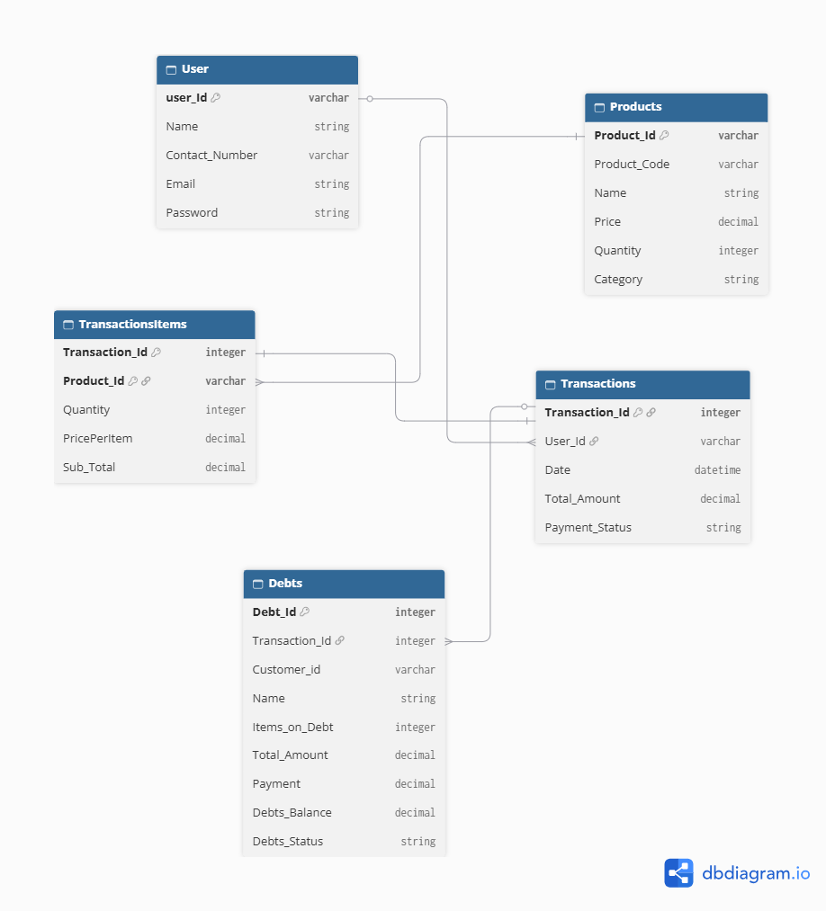

Entity Relationship Diagram Cardinalities
- User to Transactions: One-to-many (1:N)
- Products to TransactionsItmes: One-to-many (1:N)
- Transactions to TransactionsItems: One-to-many (1:N)
- Transactions to Debts: One-to-zero-or-one (1.0..1)

Figure 2: Data FLow Diagram (DFD)
Level 0: Context Diagram
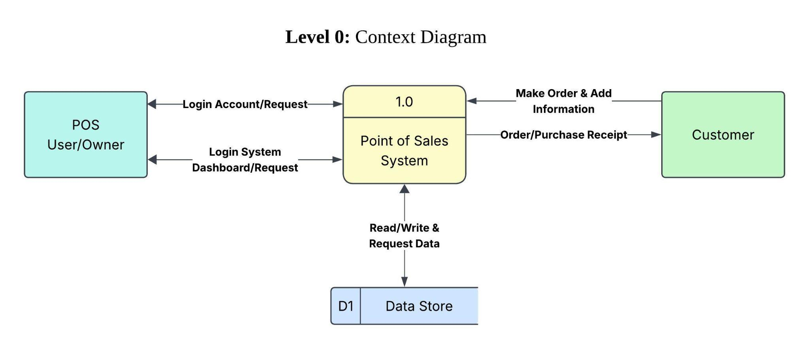

Figure 2.1: Data FLow Diagram (DFD)
Level 1: Main Functions Diagram (Major Functions)
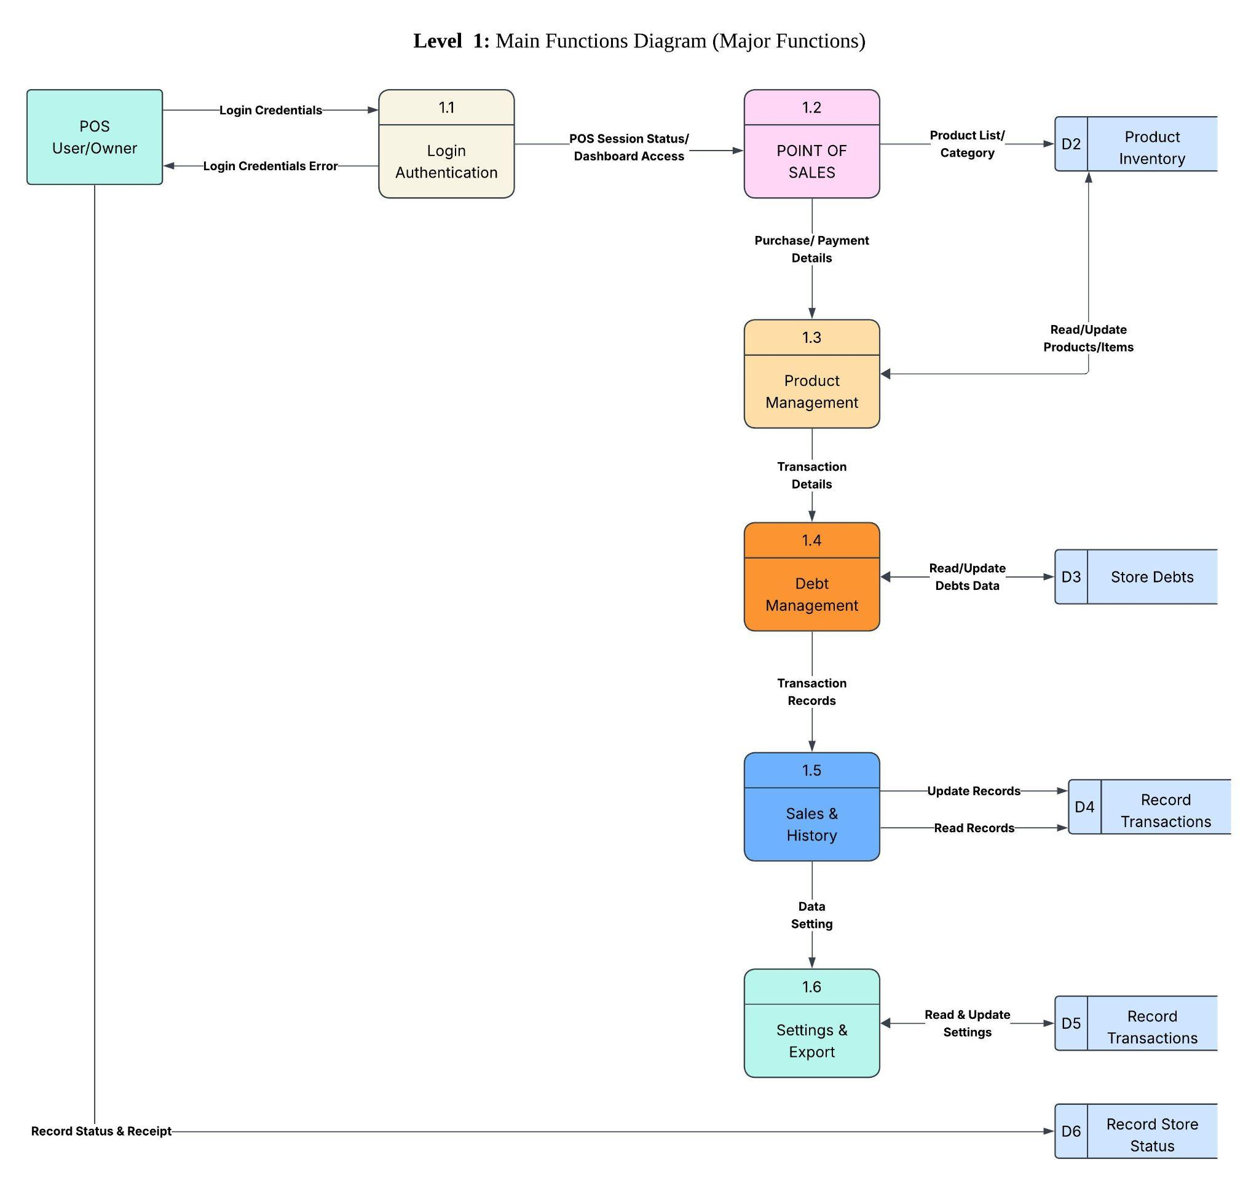
Figure 2.3: Data FLow Diagram (DFD)
Level 2: Checkout Details (Sub-processes)
